Build Your Visibility Guide

**Build Your Visibility Guide**

**“80% of jobs never get posted and are only found through networking.”**

**–** [**The Muse**](https://www.themuse.com/advice/6-insider-job-search-facts-thatll-make-you-rethink-how-youre-applying)​

**Key Takeaways:**

1. By the end of this Milestone, you will be able to develop a plan for networking and outreach.
2. Review this guide, and [mark complete on BCS](https://www.bootcampspot.com/login).
3. For more insight on networking, [click here to view a “Expand Your Network” workshop](https://youtu.be/88SeUnowE54).

Employer Competitive candidates stand out in their search by making themselves visible and selling their strengths. They're clear on their search **goals**, the **value** they're able to add to their target jobs, and the importance of **increasing their visibility** to help them reach those goals.

For a guided experience on networking, [click here to view a “Expand Your Network” workshop](https://youtu.be/88SeUnowE54).

**GETTING STARTED**

1. Review the guide below for best practices on in-person and online networking
2. If you’d like additional support with networking, see [the resources](https://careerservices.gitbook.io/career-resources-data-analytics-library/-LjRMfertuZzhAIzJI8A/build-your-visibility/build-your-visibility#additional-resources-) we’ve included at the end of this guide.
3. Once you’re done, [mark this milestone complete on the Career Services page in BCS](https://www.bootcampspot.com/login). *Reminder:* This Milestone **does not** require a submission to a Profile Coach.

**AT A GLANCE**

* ​[**About Networking**](https://careerservices.gitbook.io/career-resources-data-analytics-library/-LjRMfertuZzhAIzJI8A/build-your-visibility/build-your-visibility#about-networking)​
* ​[**Online Networking**](https://careerservices.gitbook.io/career-resources-data-analytics-library/-LjRMfertuZzhAIzJI8A/build-your-visibility/build-your-visibility#online-networking)​
* ​[**Additional Resources**](https://careerservices.gitbook.io/career-resources-data-analytics-library/-LjRMfertuZzhAIzJI8A/build-your-visibility/build-your-visibility#additional-resources)​

**ABOUT NETWORKING**

Successful networking involves building relationships, and it's important to note, that building a strong network doesn't happen overnight. It takes time and consistent effort, but it will be worth it!**IN-PERSON NETWORKING**

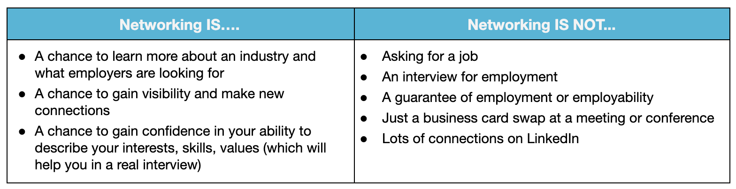

**(1) Identify Your Current Network**

You may have more people in your network than you realize. Use the categories below to help you think about who's in your network and how you might reach out to them.

|  |  |  |  |  |
| --- | --- | --- | --- | --- |
| **Family** | Friends | Former Colleagues and Supervisors | Professors, Trainers, etc | Other Connections |

**(2) Expand your Network**

**Consider the following approaches to expand your network:**

* **Reach out to every person on your networking list above**, and send them your materials with a specific task. “Asks” can include a quick chat on the phone for advice or a lunch date to talk about your target industry as well as recommendations for who you should connect with next.
* If you’re currently employed, **ask your boss for projects that require you to interact with new departments or individuals**. For example, you can propose that you help the company enhance its website, and in doing so, you'll interact with other developers and/or the marketing department.
* **Find volunteer opportunities**. Get involved in an organization or group that interests you, and offer to contribute some of your new tech skills. You may meet people who can be helpful.
* **Create business cards** that include your target role, links to Github, LinkedIn, and a QB code to scan for your resume.
* Continue to **use LinkedIn weekly to connect with employees and decision makers**. Look for people who might have secondary connections to you. Send personal messages about your passions and common interests, and request informational interviews.
* ​[**Here is a great reminder of all the many places where you can network.**](http://www.jobmonkey.com/best-places-to-network/)​

**(3) Attend Networking Events**

It’s always helpful to set a goal when attending networking events (e.g. “I will have 3 meaningful conversations that may lead to potential follow-up,” or “I will not leave until I have entered into at least 5 conversations.”). Establishing a goal allows you to set a measurable standard of success for the event, which can help change your experience of networking into a positive one.

**TIP:** Always bring business cards with you to events. On the back of the cards you receive, take notes about the person you're speaking with so that you can follow up in a personal way.

Here are some additional tips that will help you differentiate yourself at an event:

1. **Master the use of tech language** – The better your vocabulary (especially as it relates to your industry), the more impressed people will be. Being confident, articulate, and knowledgeable will help you create a strong first impression.
2. **Eye Contact** – Always maintain eye contact when you're speaking with someone. Looking away can make you appear less confident. Also, remember to smile.
3. **Leave personal space** – Don’t stand too close to anyone. Keep a reasonable distance.
4. **Acknowledge your understanding** – When someone else is talking, acknowledge that you heard them with non-verbal body language such as nodding.
5. **Wait your turn** – Successful professionals are also good listeners. Allow your new connection the opportunity to complete their thoughts before offering a response.
6. **Watch body language** – Mirror the body language of the person with whom you are interacting. If they sit down, you should sit down too— they may be ready for a longer conversation. Try not to cross or fold your arms, as that may create the appearance that you are guarded. Overall, be mindful of both you and your new connection's body language.
7. **Be curious** – Open the conversation with questions. Focus on the other person’s interests first, and show genuine interest.

​[Here are some conversation starters that might help you as well.](https://www.themuse.com/advice/30-brilliant-networking-conversation-starters)​

Networking is more about farming than it is about hunting. It's about cultivating relationships.

**– Ivan Misner**

**(4) Follow-Up**

Networking only works if you follow up! After meeting new contacts, follow up with a personal message soon after you've met.

When reaching out, whether via email or phone, here are a few tips:

1. **Remind them how they know you.** Always begin by referencing a common person, event, educational experience, work experience, organization, or award that creates a common bond.
2. **Be clear on what you bring to the table.** Express interest in the person’s work, and add value instead of asking for something. Sharing interesting articles, making introductions to helpful contacts, supporting the contact's endeavors, and engaging with their LinkedIn posts are great ways to add value.
3. **Be flexible with scheduling.** Make it easy and convenient for the contact to say yes to connecting again!
4. **Do your homework!** Research your new connections to help you better foster a relationship with them. LinkedIn and general internet searches provide instant access to information on your targeted connections.
5. **Don’t give up, and don’t take it personally.** Some people hesitate to reach out again for fear of being ignored, rejected, or of being a pest. It’s okay if someone doesn’t take you up on your offer. If you are reaching out to people regularly, you'll get more accepted invitations than passes.
6. **Breathe, and stay calm.** It’s perfectly normal to be nervous about calling people. Networking is a skill that requires practice. It may help to practice your calls with friends or family. It may also help to remember that you're not calling to ask for favors — you are asking to learn from someone. Most people love sharing their expertise!

The richest people in the world look for and build networks: everyone else looks for work. -**–**

**– Robert Kiyosaki**

**(5) Request Informational Interviews & Seek Mentors**

Informational interviews are your opportunity to explore whether your goals or current opportunities really are the right match for you. They're also great ways to expand your network through introductions from the connection you're interviewing.**NOTE:** Informational interviews should lead to more interviews, volunteer or open-source projects, or ideas about new directions to take. For more on informational interviews, check out this [article called 5 Tips for Non-Awkward Informational Interviews.](https://www.themuse.com/advice/5-tips-for-nonawkward-informational-interviews)​

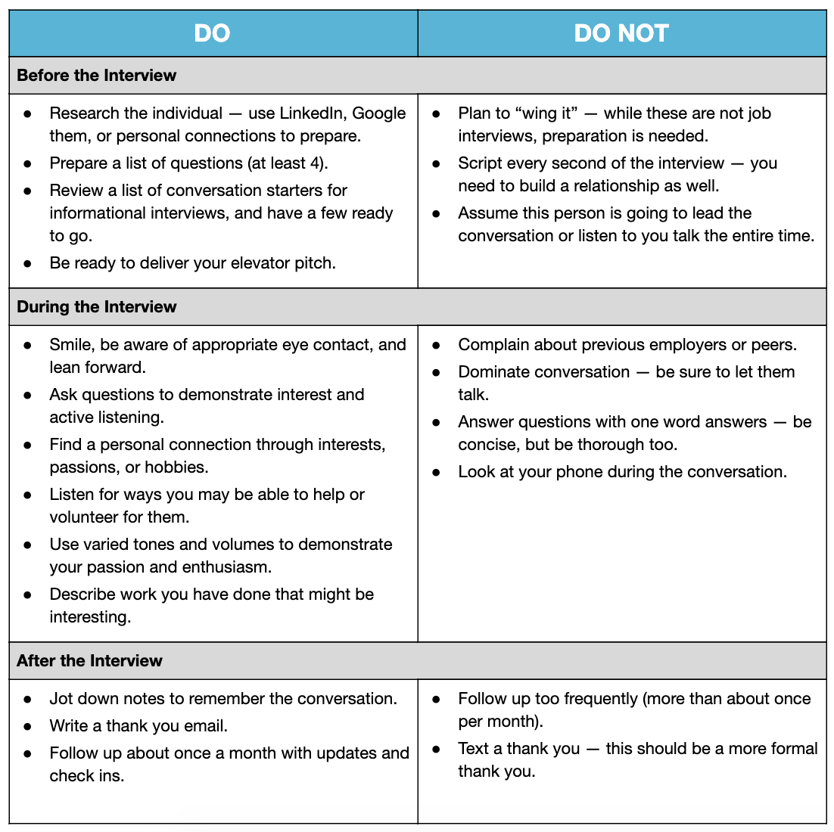

**ONLINE NETWORKING**

**Social Media**

* Make sure your profiles look polished on platforms like LinkedIn, Angel.co, and any others. Examples of excellent Web Development profiles can be found here:
  + ​<https://www.linkedin.com/in/aaronkwalker1/>​
  + ​<https://www.linkedin.com/in/abishr12/>​
  + ​<https://www.linkedin.com/in/akiyomarukawa/>​
* On LinkedIn, Facebook, and other platforms - follow companies, thought leaders, and professionals in the industry. Learn how to do this here: <http://bit.ly/2Ec5ikA>. Engage with these companies and individuals through likes and comments on their posts.
* Look for alumni groups for your current or past organizations.
* ​[Use these templates to help you draft your outreach messages.](http://bit.ly/2K70nYt)​

**ADDITIONAL RESOURCES**

* ​[10 Simple Ways to Improve Your Networking Skills](https://www.youtube.com/watch?v=E5xTbn6OnAA)​
* ​[How to Find Your Next Job Over Coffee](https://blog.udacity.com/2014/11/informational-interviews-how-to-find.html)